This document demonstrates the specification for a digital, automated, and smart tracing process for the import and export of air cargo. It starts with the import, and once done, only the main differences for export are elaborated (since the tracing in the airline and cargo terminals sites are similar).

Introduction for the Import Tracing Process:
The relevant process described below is air cargo import tracing (aircraft are also flying cargo, and not only passengers). A unique air waybill number identifies each shipment (it is the flight ticket number, as with a passenger). At the beginning of the supply chain, there is an exporter (in the origin) and on the other side an importer (at the destination). The exporters create an export shipment (one piece or many). They move the shipment to a freight forwarder, which is the agent representing them. This agent is choosing an airline and moving the shipment to the airport. The airline (using a cargo terminal) is performing all needed actions, including customs and security. The airline takes the cargo on board an aircraft to the destination, with or without a transit station. It is the responsibility of the agent to verify every step of the shipment and notify the client (exporter or importer) in real time if something goes wrong. This action is called tracing, and it needs to be done constantly since flights are global, 24/7, and regularly changing.
A large agent is dealing with thousands of air waybills per month. Tracing is one of the most significant actions being done by all agents worldwide, and it is being done manually (fully ot partly). The main core functions of a freight forwarder (agent) are to choose the route, book the cargo with the airline, issue the AWB, perform the tracing, and manage the relevant suppliers. DSV in Israel is working with two main IT systems. CargoWise is the global DSV system, and Unifreight is an Israeli system that was replaced by CargoWise but is still being used mostly with customs messages and the client Elbit. In the future, the intent is to stop using Unifreight, since DSV Israel is expected to be using only CargoWise. Still, until CargoWise covers all Unifreight's actions, it will not happen (there are many things CargoWise is not capable of doing). Since both systems are working in parallel, there is an option to create AWBs reports from both, and it will also allow comparing and verifying that the information is similar. Unifreight has a lot more Israeli-adapted processes as opposed to CargoWise and many more automated messages (and additional information such as contact person and so on).
The correct flow of movements is:
- ETD - Estimated Time of Departure ATD = Actual Time of Departure ETA = Estimated Time of Arrival ATA = Actual Time of Arrival.
- ETA is usually calculated after the ATD and updated during the flight according to actual conditions (wind, route, delays, etc.). In some aviation systems, we might see STD/STA (Scheduled) instead of Estimated, but it is the same sequential logic (STD STA, ATD → ATA)
Air Way Bills:
- House AWB - shipping contract between the agent (freight forwarder) and the shipper.
- Master AWB - shipping contract between the airline and the agent (one MASWB can include one or several HAWBs).
- Direct AWB - shipping contract between the airline and the shipper. One AWB, no consolidation, no Master or House AWB. For some shipments, it makes more commercial sense to send them under Direct AWB; it also allows better control over the shipment; some are not allowed to be sent in consolidation, etc.

Import Tracing Initiation
- An import shipment can be initiated by DSV Global, a client overseas, and a client in Israel. In certain cases, DSV Israel will be relevant for an import shipment only when arriving in Israel, and in other cases, from the beginning of the journey. In this document, we refer to the full journey since it covers all options.
- The Israeli customer is approving a certain shipment (after an approved job proposal), and DSV Israel is approaching the relevant DSV branch overseas (via mail or Unifreight). Around 99% of cases are dealt with DSV branches, but from time to time, there is another agent involved.
- The Israeli import department will open a file in Unifreight, and the information is sent to the other side's CargoWise system, which opens a file with a unique file number (prior to an AWB).
- In this stage, there is usually a land transportation to the relevant warehouse overseas, and this is when the AWB is issued, and the tracing can begin. It might be that certain tracing can be done with trucking and 3PL companies that show information on their sites.
- In this stage, it is available in DSV and Schenker systems (Schenker is an agent that DSV bought), but not in airline systems.
- Once there is a booking with an airline, the full tracing (internal and external) can begin. In certain cases, airlines will show an AWB on their sites only once accepted into their warehouse.
- Up to this stage, there might be an extensive email exchange for information (refusal, weight, volume, difficulties, transportation, delays, logistical issues, and more).
- Prior to COVID, there were a lot of "line" movements. Regular movements with a lot of regular operations. Everything was more moderate (less involvement in these shipments). Since COVID, most shipments require spot handling, including tracing of all movements, spot price quotes, and more.
- As soon as the shipment arrives at DSV's warehouses or at the port, the Israeli operations staff takes control and traces the entire container/console. The customer service Israeli employees will track specific shipments that are not in the consul or shipments that are "colored red" because of their importance. Still, the operations staff handles most of the shipments.
- As soon as there is a consular bill of lading, the entire consignment is tracked. The line managers monitor the process.
- Summary: Customer request - price quote to confirm - green light from the customer - Input to Unifreight - create contact with the overseas branch - open a shipment order (SHO) - all relevant details - an automatic message goes out to the branch - The contact details of the overseas supplier are processed automatically - all the handling happens through the SHO - There is a ping-pong of messages (such as when the supplier announces that the shipment will be ready) - everything is in Unifreight (enter all the information that is received and the messages go out automatically) - Even the buyer can be involved here between DSV and the overseas supplier (he is actually the exporter) - When, for example, there is a shipment that will be ready in a week, there is a digital "taf taf" including the delays (a kind of dashboard) that generates daily monitoring of all pending shipments - the DSV branch abroad generates the information in CargoWise - the link between the systems occurs automatically - it is a point that is quite close to its departure - the shipment moves to the warehouses or port, and when it is ready at a certain time, it will receive a Bill of Lading/AWB and from this point the tracing begins, and from here, the work with CargoGent begins.

Step 1: Excel Extraction
- This step starts after the agent (DSV) somewhere in the world has made a booking for a shipment with an airline and received an Estimated Time of Arrival (ETA) to Israel. DSV Overseas is notifying DSV Israel about this information via CargoWise to Unifreight. The shipment can be physically anywhere, but most likely it is still overseas before the flight.
- As soon as an AWB is opened in Unifreight, the classic tracing process begins. DSV employees are verifying that the data is optimized (making sure that no information is missing, cross-referencing the information with the file in CargoWise and with Unifreight manually). It is possibly an action that can be done by a Robotic Process Automation (RPA) if DSV chooses to allow access to the systems. Without the access, this action is done by comparing the two Excel files mentioned below.
- DSV Israel will collect this information on Excel, and a structured Excel sheet will be delivered to CargoGent by mail in set intervals, determined by DSV (every several hours).
- The Excel will include all the AWB-relevant information DSV will choose. Example:
- The first step should include the retrieval of the two Excel files (mail or directory). DSV will deliver two similar Excel sheets to CargoGent - one from Unifreight and one from CargoWise.
- The next step is verifying that the Excel being used is a new and correct version.
- The next step - CargoGent will verify that the two Excel files are similar. The AWB number is similar between the two Excel files, and the rest of the information to be compared is to be defined by DSV to allow optimal comparison. Not all the information delivered from CargoWise to Unifreight is moving correctly, and that creates a situation in which these AWBs don't exist in Unifreight. The aim is to flag all the mismatches or missing information in either of the files.
- The next step - CargoGent will notify DSV of any (pre-determined) discrepancies (email or Excel with red lines or other form of notification chosen by DSV).
- The next step is to extract the Master bill number from every line in the relevant column (might be a few hundred lines in each file). The extraction includes all digits.
- DSV will send only the airlines for which it has agreed in advance that CargoGent can search their sites and extract data. The number of airlines is not limited, and the decision is based on the airline's site being able to supply the needed data in a structured format.
- The next step is for CargoGent to verify not to extract Master AWB numbers that have already been solved in full (the ATA in Israel is completed, meaning the shipment landed in Israel).
- The Excel holds all the Master Airway Bills, which are the flight tickets for air cargo flying as a consolidation. The consolidation is a group of House Airway Bills (each HAWB is a contract between DSV and a client) grouped as one shipment for a better price under a MAWB (which is the contract between DSV and the airline for a specific flight - similar to passengers deciding to fly as a group). In certain cases, there might be only one House in a Master.

Step 2: Track-Trace
- The shipment can still be physically anywhere, still overseas before the flight, or onboard the flight. In certain cases (rare), it may have already landed in Israel.
- The first step is to enter the site https://www.track-trace.com/aircargo.
- The next step is to verify that the search field is empty.
- The next step is to implement the master bill from the Excel into the relevant field on the site and press the "Track direct" button.
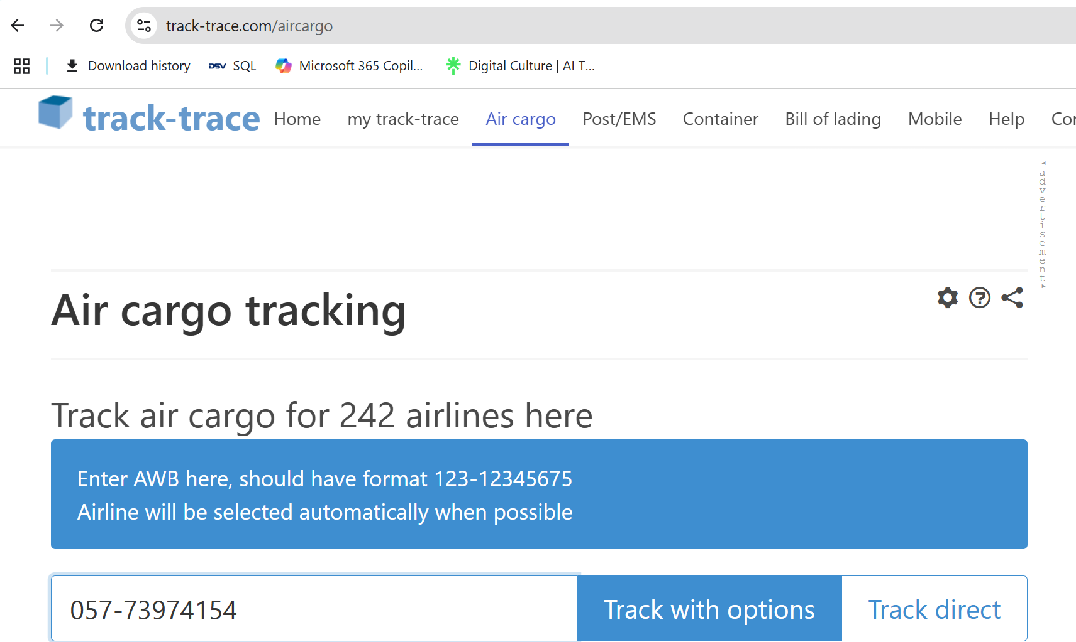
- The next step is to initiate a search. The site opens the relevant airline site that holds the information about the shipment (first 3 digits represent the airline, for example, El-Al is always 114). Example for a site snapshot:
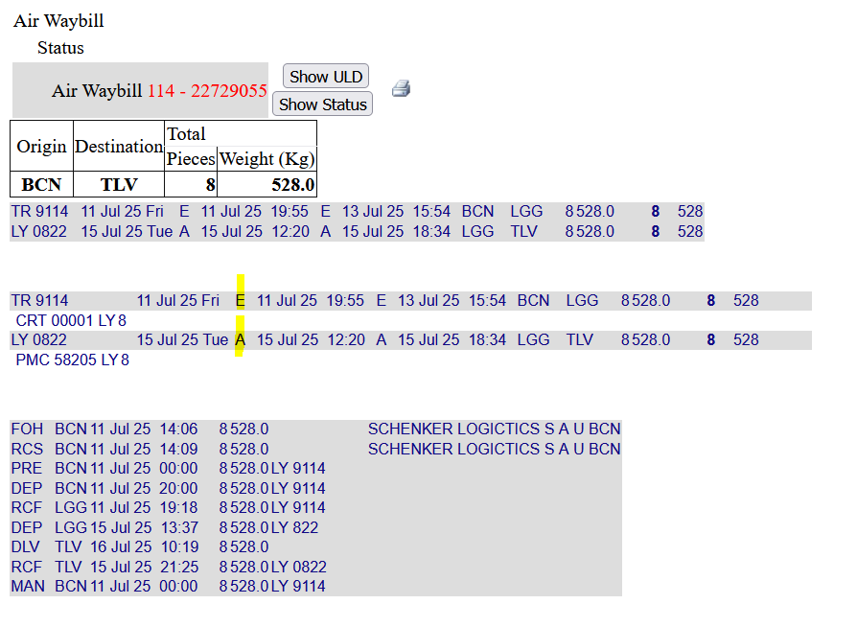
  - The example above includes a marker in the ETA and ATA lines. If the shipment is still on the way, there will not be an ATA line.
- CargoGent will take into account that the airlines' sites are structured but different from one another in the way they are shaped and hold the data. DSV will pre-determine the fields of data that need to be compared between the Excel files and the airline site.
- CargoGent will take into account that if a better option to retrieve information from airline sites is possible, it will replace the Track-Trace site.
- The next step is for CargoGent to be able to read the information presented on each airline's site and compare it to the Excel files. If there is a new piece of information (such as a different ETA or a new ATD), CargoGent will update the Excel in the relevant column. It is important to emphasize that CargoGent is updating new information, but also validating existing information.
- It is important to mention that CargoGent will verify all the information, not only movements. It means checking if the number of pieces on the site matches the number of pieces in the Excel, if all pieces are moving together (no split is done, meaning only X out of Y pieces departed), and so on. Every discrepancy that indicates a problem will need to be checked, and these discrepancies will be pre-determined by DSV.
- It is important to mention that CargoGent will be rechecking every shipment as many times as needed until it moves to the pre-determined desired stage, which means a certain piece of information is not relevant anymore. For example, if a shipment receives an ATD, the Excel will still include the shipment, and this information will still be checked with every entry to the airline site until there is an ATA. The reason for this is that the airline's sites are not always accurate, and it might be that the information will change, or it is misleading.
- In addition to the above - CargoGent will include some "logical" components that are pre-determined and are meant to raise a flag for the user if something not reasonable is happening. For example, if a flight includes an ATD of a 3-hour flight, but after 5 hours, there is no ATA, CargoGent will send an alert to the relevant user.
- The next step is for CargoGent to send an alert for any pre-determined discrepancy (mark in red this AWB in the Excel and add an email, or any other form determined by DSV). Examples are ATD is not as scheduled, the number of pieces doesn't match, and so on.
- The next step is to deal with site irregularities in the correct way. In certain cases (probably around a single-digit percentage), the airline site reflects an unusual incident, and/or it might be that the information is not structured regularly. If CargoGent is incapable of resolving that and extracting the data, it will need to issue an alert to the user (by mail and/or inside the Excel) that a specific Master Airway Bill was not updated due to site failure. CargoGent should not, in any case, and under any circumstances, update the Excel with incorrect information.
- The next step will include support for the tracing employees to track the shipments. Today, the employees are managing remarks inside Unifreight to remind themselves what needs to be done with every AWB. CargoGent will support that with remarks implemented into the Excel (or a different format of messaging chosen by DSV). For example, an AWB is scheduled to depart in 4 days - the employee places a note in Unifreight today to remind themselves to recheck the shipment in 3 days. CargoGent will constantly check the shipment (additional value since today it is not being done, and so changes will be reflected earlier). Cargogent will place remarks (or another sign pre-determined with DSV) so the employee will know the shipment was checked.
- The employees must trust the process!

The Cargo Terminals
- In this stage, CargoGent is trying to locate the shipments that landed in Israel and have been accepted by the cargo terminals in Ben Gurion. There is an operational internet site for each cargo terminal in Ben Gurion.
- It is important to mention that in certain cases, there might be a need for CargoGent to enter a username and a password to extract information. This capability should be in place.
- The entry into the correct terminal internet site is done by identifying the airline - each airline works only with one terminal.
- It is important to mention that this stage works both with the MAWB and the HAWB (which was not used until now). This information will be included in the Excel files.
- The next step is for CargoGent to enter the import shipment search page on the Maman Cargo Terminal site. A search will be created by using the Master (without the first 3 digits), the airline code (3 digits), and the House AWB (without the first three letters/digits).
- The next step is to update the Excel files with the right information based on the data in the cargo terminal sites. The first data is the ATA, but from here, many additional pieces of data can be relevant. For example, how many pieces landed, weight, special handling code (such as refrigerated), accepted with damage, and more. What needs to be checked and what needs to beupdated will be pre-determined with DSV in advance.
- The next step - some pieces of information are critical, and CargoGent will have to alert the user in real time. For example, a shipment that was not accepted in full. In a case such as this, CargoGent will have to constantly follow the cargo internet site to verify when the next pieces arrive and do so until the shipment is complete. A mismatch between the Airline site and the cargo terminal site might occur and should be flagged (the airline reports sending 16 pieces, and the cargo terminal reports accepting only 14).
- Example for a snapshot from the Maman site:
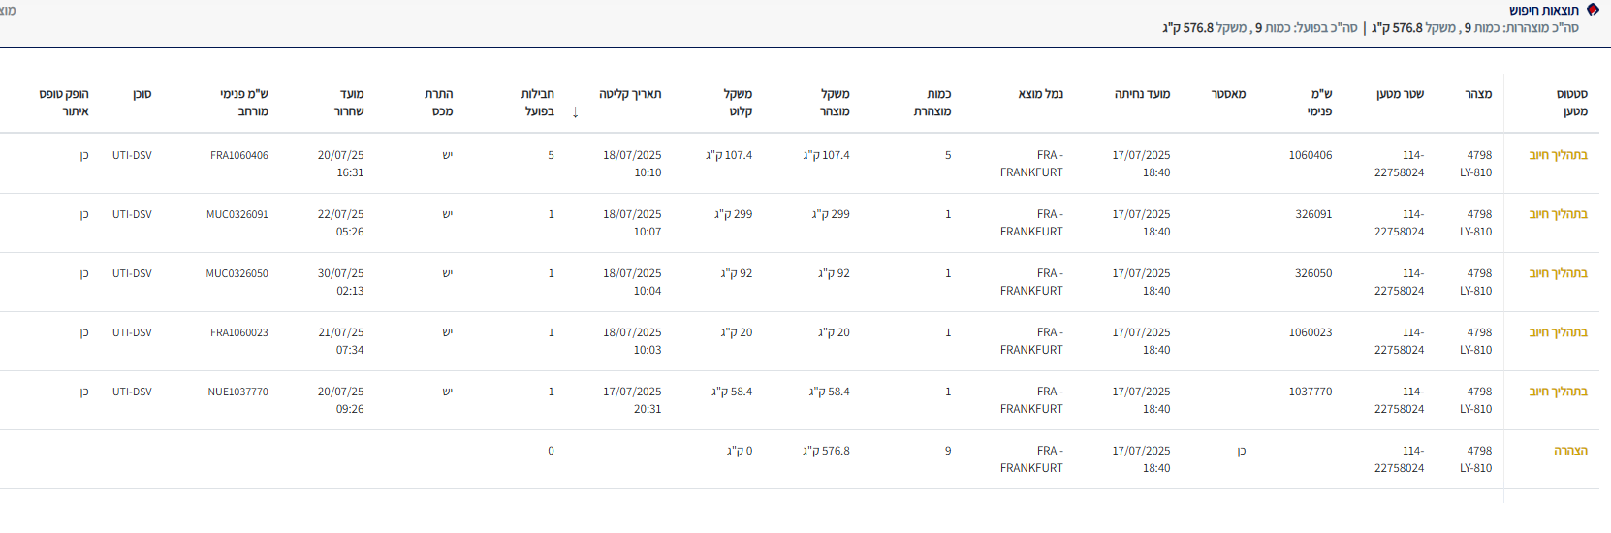
  - We can see in the above picture that there is "תאריך קליטה", which means the shipment was accepted. We can see the total pieces at the bottom. You can also notice that one piece was accepted on July 17th and the rest on July 18th.
  - We can see the above shipment has 9 pieces under one Master bill, but 5 different house bills (ש"מ פנימי) representing 5 different shippers. DSV is concerned about the total 9, but CargoGent should be able to track the shipments on a House Airway Bill level.

- It is important to mention that, similar to the airline's sites, whenever there is unusual information in the cargo terminals' sites, if CargoGent is unable to resolve that, it needs to issue an alert to the user that this specific MAWB or HAWB was not updated. CargoGent should not, in any case, and under any circumstances, update the Excel with incorrect information.
- Another step that needs to be performed by CargoGent is the tracking of messages. The cargo terminal sites are capable of sending messages with updates. They are being sent today to CargoWise. CargoGent should have the capability of retrieving these messages and comparing their data to the Excel files for better accuracy. If, for some reason, the message doesn't arrive at CargoGent, another possibility of detecting the information is by comparing the CargoWise Excel to the Unifreight Excel, as mentioned at the beginning of this document.
- Another step that needs to be performed by CargoGent is to do with messages sent from DSV to the cargo terminals. Before every landing (and not later than 3 hours before landing), DSV needs to send the HAWB numbers to the cargo terminal with an indication of which MAWB they belong to. The cargo terminal receives a message from the airline about the flight cargo, but it includes only MAWBs. If the DSV message doesn't arrive, the cargo terminal will accept the flight on a MAWB level only, and it will demand a correction later by DSV, slowing the process. On top, from time to time, the message is sent from DSV to the cargo terminal, but due to a technical fault, it is not being received (or there is a mistake in the content). CargoGent will be accepting these messages as well. Their content will be checked, and any discrepancy will be flagged. On top, if the 3-hour window is about to be closed and no message was sent, CargoGent will flag the user.
- Another step that needs to be performed by CargoGent is to verify that the cargo terminals have accepted the message above, either by accepting an approval message, by checking the cargo terminal site, or by accepting an approval email sent by the cargo terminals. All three options should be valid and operational.
- Another step that needs to be performed by CargoGent is the tracking of the Special Handling Code (SHC). Some shipments are in need of special handling, such as special storage or a faster acceptance time. The information is not always clear and needs to be subtracted from the commodity or special handling fields. DSV will verify that all relevant information is included in the Excel, and CargoGent will have to implement some rules that, if + if + if = an alert, based on a comparison between the data in the Excel files and data in the cargo terminal sites (and/or messages accepted). For example, if a certain shipment was identified as refrigerated (2-8 Celsius), CargoGent will check the status from the cargo terminal indicating the right storage place.
- Another step that needs to be performed by CargoGent is constant tracing on the cargo terminal sites to detect changes in the status of the cargo. Customs release, for example, or cargo clearance to a trucking company (the end of the tracing process since the cargo left the cargo terminal site). DSV will pre-determine in advance what information it aims to receive as an alert.
- Another step that needs to be performed by CargoGent is similar to what was mentioned above - CargoGent should be capable of notifying the employees about the tracing being done to create trust and to override their need for constant notes and remarks to track the shipments. On top, there should be some logic implemented into the process that if something "not logical" has happened, CargoGent will flag it to the user (for example, a shipment was accepted in the cargo terminal on a certain date, a message was sent to the trucking company to pick up, but the shipment is not cleared 2 days after).
- The end of the Import tracing process is once all pieces have left the cargo terminal in Israel.

General (for both Import and Export)
- The above raises an important note - CargoGent is tracking shipments based on the Excel files being received from DSV. Parallel to that, CargoGent is running a separate tracing for shipments that are under "surveillance" and not necessarily still included in the Excel. These shipments are the ones that require additional actions to be confirmed, and only once they arrive at the pre-determined final stage, are they deleted from CargoGent data.
- CargoGent should also be able to consolidate alerts. In certain situations, there might be several delays or irregularities with certain shipments. It might not be clear to the employee dealing with the shipment. CargoGent will now know how to aggregate information in a form that, once a certain pre-determined threshold is crossed, an alert will be sent.
- An important note to emphasize is that the Excel files will include Direct, Master, and House AWBs. For every Master that includes several Houses, the Master lines will be duplicated several times to match the number of Houses under this Master (Direct AWB will have one line). When there is no ability to match a certain piece of data to an exact House (such as partial acceptance of a master in the cargo terminal), the alert or information will be duplicated to all House Airway Bills in the Excel files with a special mark indicating it is partial information.
- Another important note - CargoGent must keep all data in one database with a full history log and not separate Excel sheets. That data needs to be kept organized for several reasons. First, integrity and sanity checks. Second, to be able to analyze the data and perform AI and machine learning processes. Third, to allow additional extraction of data for future processes. It is a "back-office" for CargoWise and Unifreight.
- A future step to review - before the AWB is created and the tracing overseas begins, the shipment is moving under a job number that might be possible to trace in the trucking companies and 3PL (third-party logistics). It is an additional value. On top of that, once the shipment is cleared from the cargo terminals in Israel, there is an additional tracing that might be possible for the "last mile".
- This document indicated the tracing process for air cargo, but once established, it should be possible to duplicate it for sea cargo. It is a different scope of work, but if designed correctly, the work being done for air cargo should suffice for the alternation to sea cargo.

Introduction for the Export Tracing Process:
Many of the tracing actions for export are similar to import and are just being done in the opposite direction of the air cargo flow. On the other side, the export has some uniqueness that needs to be emphasized to verify that CargoGent is supplying the full solution.
The supply chain starts in Israel with the shipper (Exporter/Consignor) asking DSV Israel to ship a certain shipment to a destination overseas. Some shipments are per demand, and so there is a need for a proposal to be approved in advance, while some shipments work on a permanent basis and under a set agreement with the shipper.
Some shippers are working with DSV's My DSV system, which allows them to submit their request, the shipment information, and also to get a quote. It is probably 35-50 percent of shippers. The rest will send their request via email with or without an attachment (PDF/Word).
Once the quote is approved, the shipment is handled by the customer service team. It is picked up (sometimes DSV is in charge of land transportation, and sometimes it is not) and moves to the cargo terminal in Israel. Throughout the entire process in the cargo terminals, it is handled by the customer service team, and once the flight departs, the dedicated tracing staff starts the tracing process.

Tracing Initiation
- The tracing process starts once the shipment is accepted in the cargo terminals, regardless of the unit handling it in DSV.
- In export, there might be a stage at the beginning where a shipment is moving only under an HAWB without a master. It means that the Excel files need to allow this option. Once several HAWBs are consolidated under a Master, CargoGent should be able to know how to detect that and organize the Excel and the search accordingly.
- HAWBs are accepted in the cargo terminals, which will also weigh them and send the information to the agent (to be stated on the AWB). Once customs and security clear them, the agent will consolidate them with the airline as part of the booking, and the Master AWB will be issued.
- It is important to mention that for the largest client (Elbit), all messages are out of Unifreight and only invoices are done through CargoWise. It means that DSV will have to initiate two Excel files in export, similar to import, to allow the ability to verify that the two systems are aligned. There is a good chance that RPA and automated solutions will be much easier to develop with Amital (which developed Unifreight), other than DSV Global (CargoWise).

The Cargo Terminals in Israel
- This stage is very similar to the import one when it comes to the collection of data from the cargo terminals in Israel. The main difference is the information itself and the place and way it is being detected in the sites.
- The first stage for CargoGent is to receive the AWB numbers (HAWB or direct level) and check the status at the cargo terminals. CargoGent should reply with a result. If not found yet, meaning the shipment has not been accepted in the cargo terminals, CargoGent should mark the search for the employees to know the last time a check was conducted. It is important to mention that if a shipment is destined for a certain airline and the information is clear in the Excel, then CargoGent knows which cargo terminal to check (other than one airline (CAL) that works with both cargo terminals). If the information is not clear, there is a need to check both cargo terminals. It is probably best to run the entire list every time with both cargo terminals.
- The next stage for CargoGent is to constantly follow the shipment status with the cargo terminals and update the Excel files and the employees. A shipment can change its status several times (storage location, customs clearance, security clearance, special orders, etc.). The final stage is the build-up, meaning the shipment is loaded into a Unit Load Device (ULD), which is the Pallet/Container/Bulk, meaning the way it will board the aircraft. At this stage, the cargo terminal has finalized its duty, and the airline assumes responsibility to verify that the shipment will be loaded onto the aircraft in time.
- Some information must be checked on the site, and some can be accepted as a message from the cargo terminal.
- The end of this stage is once the shipment is either ready to fly (after build-up) or once there is an ETD. At this stage, the tracing employees assume control. CargoGent should be able to realize by each stage of the process who the relevant employees/units at DSV are for the updates and messages (and mostly while raising flags).

Track-Trace
- This stage is very similar to the import stage when it comes to the collection of data from the airline's tracing sites.
- When entering an air waybill in CargoWise by tapping on it, there are several possible tabs. If the word automation appears in the workflow tab, it means that CargoWise automatically initiates a tracing process with the airline for the departure date and arrival date (done with the majority of airlines). It knows how to contact the airline via EDI and receive the information from its systems. DSV's problem is threefold: one, sometimes the information is inaccurate. The second problem is that once the shipments receive DEP status, they disappear from the consoles' search screen. The third problem is that if the airline moves the information and changes the process, and the tracing employee does not know. On top, new information CargoWise runs over old information, leaving no trace to know there was a change. It is expected of CargoGent to be able to constantly monitor the shipment to identify the appearance of information and the change or disappearance of it.
- CargoGent should be able to keep logs of changes or old Excel information for each AWB to notify DSV once a notification from an airline has changed. If the airline committed to a certain ETD and it changed after implemented into CargoWise, it is important to notify the relevant employee. Similar to the export, it means that CargoGent is not working only by information sent in the Excel files but also by information kept in the memory of the CargoGent database, based on pre-defined rules. These searches for changes in information should be performed every several hours.

- Since some fields are being updated in several different locations in CargoWise, but only some are changing (such as the ETD in the AWB file entry that doesn't change and the ETD in the AWB page that does) if the Excel files are being constructed correctly CargoGent should be able to constantly compare the new and the old data to reflect on changes that should be flagged.
- There are different airline statuses. There is booked (for a flight), accepted (the cargo terminal), Manifested (built up for flight), DEP status for the first leg, ARR (arrival) for the first leg, and Received for the first leg (in all of them, the number of packages and weight must be checked). For the second leg, the same process until arrival. Upon arrival at the final destination, there is a ready-for-collection status. At the end, there is a Delivery status (it means DSV or the customer has collected the paperwork). It is important to mention that not every airline has all of these statuses. Most airlines have a DEL (delivery) status, which is important because every arrival +24 hours begins to generate storage costs.

Overseas
- It might be a benefit to the export process that doesn't exist in the import, and it is the ability to collect data from the cargo terminal sites overseas. It allows the benefit of overriding the airline information that is not always accurate with direct information from the cargo terminal. A note to check is whether it is possible, since not all cargo terminals worldwide have operational sites, and with some, the information is limited (it might be that DSV Israel will not have permission to collect data). It is an option to review and add whenever possible to create additional value. Still, even if it doesn't happen, the airline is supplying the data anyway.
- When a shipment arrives overseas, it is not always the responsibility of DSV to handle the shipment and do the tracing. Only shipments with the Incoterms type D are relevant (unless the client requests otherwise).
- When the shipment reaches its final destination, it is tracked with DSV stations around the world via email in cases where the information is missing in CargoWise (because if the information is in the system, an email is not needed). It is mainly the information for the estimated time of arrival and actual arrival to the customer at the end of the journey that is needed. Any action CargoGent can add here will be a great value. In the US, FedEx is used for land transportation. The FedEx tracking number is entered into CargoWise, and the tracing personnel track it on the FedEx website to verify arrival. DSV will produce a report, and CargoGent will do the tracing on the FedEx site.
- If another agent collects the shipment at the destination, then tracking is only done via email. Usually, there is no website that can be used. If CargoGent is able to produce an automatic email, such as "Please update status" with an AWB number, it is beneficial.
- If there is a split of a shipment or any other problem, the employees write notes in the tracking field in the system to remind themselves of further handling. Night flights also contain remarks so that they do not look for them during irrelevant days (only the day after takeoff). It is expected from CargoGent to support the employees by saving the need for these notes as the system updates them on all the searches done, and creates trust.
- There are situations where there is also an error in the destination. It is also a piece of information that is important to compare (an unusual but critical error).

General
- There might be stages where an AWB will be accepted or traced under the wrong number by the airline or a cargo terminal. CargoGent should detect that by identifying that a Master has the wrong House or the opposite (compared to the Excel files). It can be relevant for import and export.
- The ability to generate emails and send them to employees to approve and forward to the client is a great bonus. The employees are dealing with many emails, and some are repeating themselves. For example, an email with a question to the overseas agent about the status of a shipment.
- The ability to generate additional information about the route, the airline, the country, etc., is an amazing value. Extreme weather conditions, a strike at an airport, irregularities with an airline, holidays, closed airports, and so on.

